COGNIZANT DIGITAL NURTURE 5.0 – DEEPSKILLING
WEEK 1 : Advanced SQL Mandatory Exercises
Submitted By
Name: Muskan Sharma
Email: muskansharma0215@gmail.com
University: C. V. Raman Global University, Odisha
Exercise 5: Return Data from a Stored Procedure
Goal: Create a stored procedure that returns the total number of employees in a
department.
Steps:
1. Define the stored procedure with a parameter for DepartmentID.
2. Write the SQL query to count the number of employees in the specified department.
3. Save the stored procedure by executing the Stored procedure content
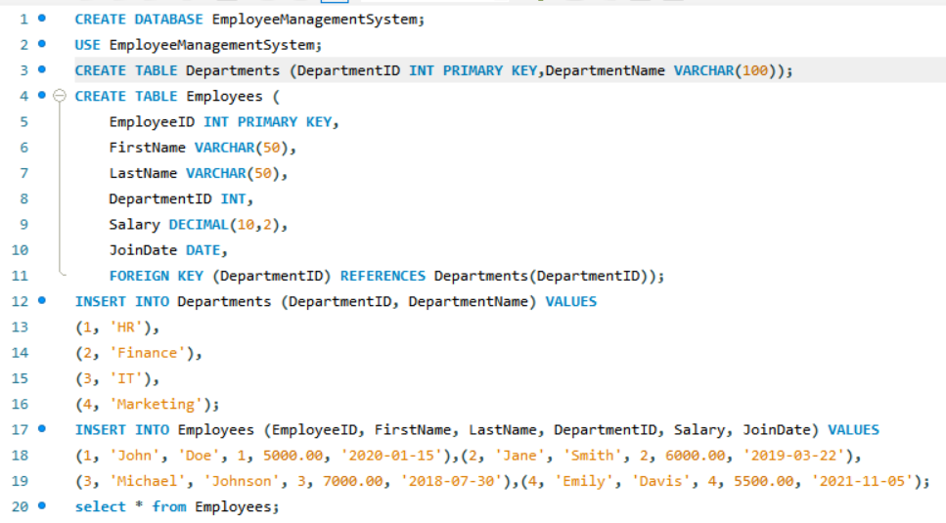
Creation of Table:

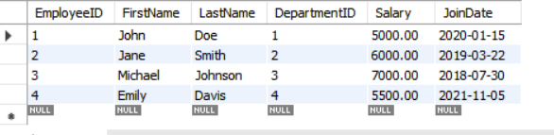

solution for Exercise 5:
